SECURE FILE STORAGE SYSTEM WITH ENCRYPTION AND ROLE-BASED ACCESS CONTROL (RBAC)
Design and Implementation
Department of Computer Science and Engineering, TKR College of Engineering & Technology
Batch C13 (CSE-C) · Academic year [ACADEMIC YEAR]
Table 1: Project team
S.No. | Student name | Roll number
1 | Pramod Reddy Yalala | 23K91A05J9
2 | Pendela Vyshnavi | 23K91A05J1
3 | Luke Abraham Sam | 23K91A05D4
4 | Mudavath Suresh | 23K91A05G2

Project guide: D V V Deepthi
Chapter and section numbers quoted in the text (for example Chapter 8 or Section 6.2) refer to the full project report, 17.Final Document. Figures and tables in this document are numbered from 1.

1. DESIGN
This chapter describes how CipherVault is put together: the architecture and workflow, the data flow, the UML and data design, the cryptographic design, the modules, the API and the user interface. The diagrams were drawn from the code in backend/app and frontend/src; the complete set, each with a longer explanation, is also in the Block Diagrams document. A note on scope: the product is a single-organisation file vault with three roles. It has no groups, no administrator console, no multi-factor authentication and no chunked transfer, and these absences are design choices that the sections below explain rather than hide.

1.1 Design goals and architecture
Five goals shaped the design. First, confidentiality against the server: the server must be able to store, authorise and audit files without ever being able to read them. Second, least privilege per file: a person's rights are attached to each file as Owner, Editor or Viewer and are checked on the server for every request, never trusted from the client. Third, integrity visible to the user: a downloaded file is accepted only if both the AES-GCM tag and the stored SHA-256 verify. Fourth, accountability: every sensitive action, including refused ones, leaves a hash-chained audit entry. Fifth, small and standard parts: the cryptography is composed from the primitives of the Web Crypto API [30] and the server uses a conventional stack, so the design can be reviewed in full.
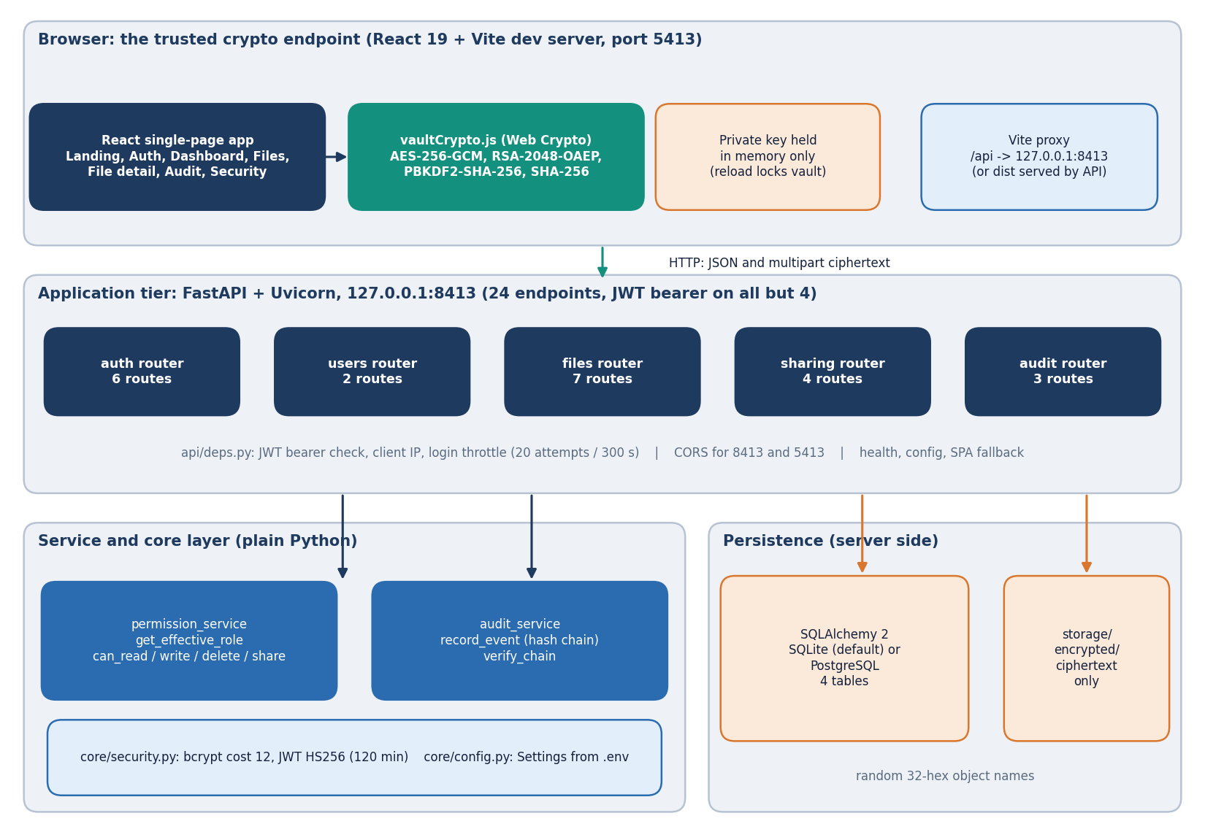
Figure 1: Layered architecture of CipherVault: the browser as the cryptographic endpoint, the FastAPI application with 24 endpoints, the service and core layer, and the database and ciphertext store.
The browser tier is a React 19 single-page application built with Vite (port 5413). Its vaultCrypto.js module wraps the Web Crypto API (AES-256-GCM, RSA-2048-OAEP, PBKDF2, SHA-256), and the unlocked private key lives in memory only, so a reload locks the vault. The Vite proxy forwards /api requests to the FastAPI application on port 8413; after npm run build the same process serves frontend/dist. The application tier consists of five routers (auth 6 routes, users 2, files 7, sharing 4, audit 3) plus the health and config routes, 24 endpoints in all. All but four of them require a JWT bearer token, which api/deps.py checks together with the login throttle. Two service modules sit behind the routers: permission_service decides the effective role of a caller and audit_service writes and verifies the hash chain; core/security.py provides bcrypt (cost 12) and JWT HS256 tokens. Persistence is a SQLAlchemy database (SQLite by default, PostgreSQL through DATABASE_URL) with four tables, and a storage/encrypted directory that holds ciphertext objects under random 32-hex names.
In development the React application is served by Vite on port 5413 and the Vite proxy forwards every /api request to the FastAPI application on 127.0.0.1:8413; after npm run build the same FastAPI process serves frontend/dist, with a fallback route that returns index.html for any path that is not an API route or an asset, so the browser sees one origin. CORS is nevertheless enabled for the two local ports. Configuration comes from the environment (.env), and the database is chosen by one URL, so SQLite for a local run and PostgreSQL for the Docker deployment need no code change.
The deliberate gaps in this architecture are worth stating. There is no job queue and no background worker: every request is handled inside the request. There is no server-side session store: a JWT is valid until it expires (the logout route only writes an audit event). The login throttle lives in process memory, so it is reset by a restart and is not shared between several worker processes. The storage layer is a directory of files named by random 32-hex-character strings, which keeps original names out of the file system but also means that integrity of the folder depends on the operating system.

1.2 High-level workflow
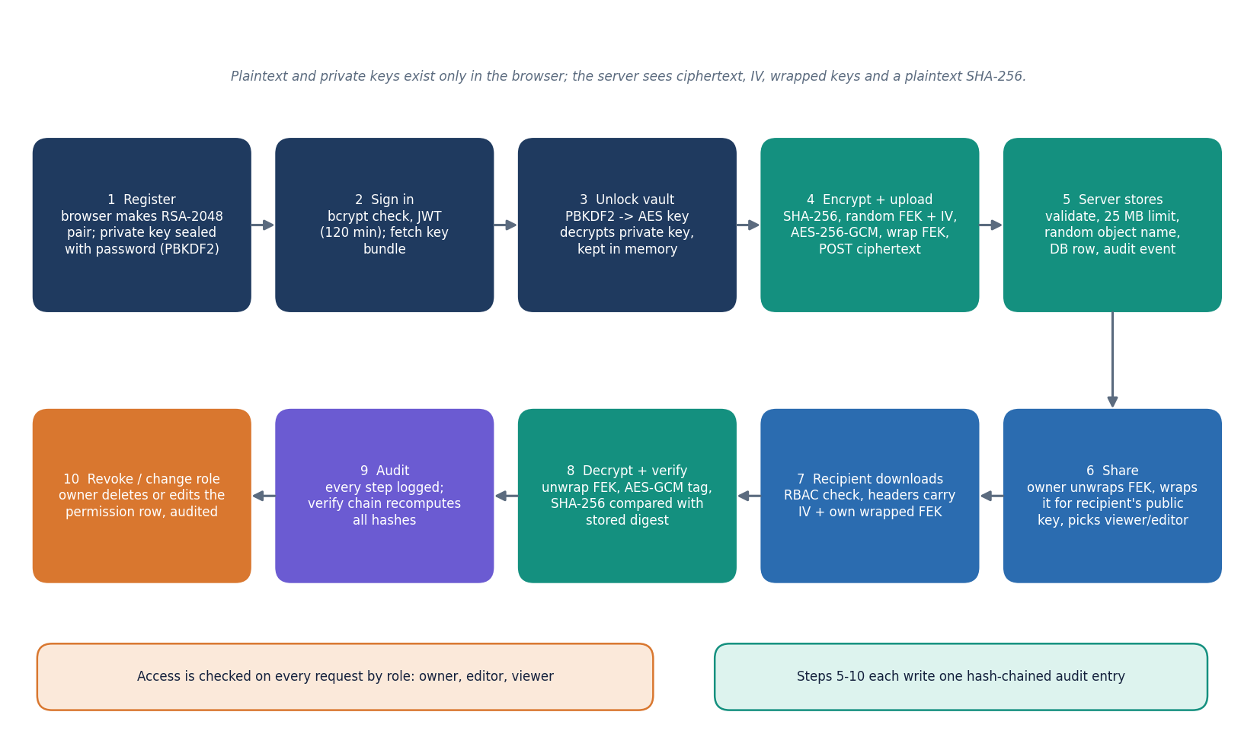
Figure 2: End-to-end workflow: register, sign in, unlock the vault, encrypt and upload, store, share, download and decrypt, audit, revoke.
At registration the browser generates an RSA-2048 key pair, seals the private key under an AES key derived from the password with PBKDF2, and sends the public key and the sealed bundle (the server hashes the password with bcrypt). Signing in returns a JWT valid for 120 minutes; the browser fetches the key bundle and unlocks the vault by deriving the same key from the typed password. To upload, the browser hashes the file with SHA-256, draws a random 256-bit file key and 12-byte IV, encrypts with AES-256-GCM, wraps the file key with the owner's public key and posts the ciphertext. The server validates the request, writes the ciphertext under a random name, inserts the files row and records an audit event. Sharing re-wraps the file key in the owner's browser for the recipient's public key and stores it in a file_permissions row. A recipient downloads, unwraps, decrypts and compares the digest before saving. Every step writes a hash-chained audit entry, and the audit page recomputes the chain on request.
Two properties of the workflow drive the rest of the design. The first is that every step that touches file content or key material happens in the browser, and the server's role is limited to validation, storage, authorisation and logging. The second is that sharing is an operation on keys, not on files: the owner's browser unwraps its copy of the file key, wraps it for the recipient and posts the 256-byte result. The server cannot perform this step itself, which is why a recipient who has not registered cannot be given access and why an owner who is locked out of their own vault cannot share.

1.3 Data flow diagrams

1.3.1 Level 0: context
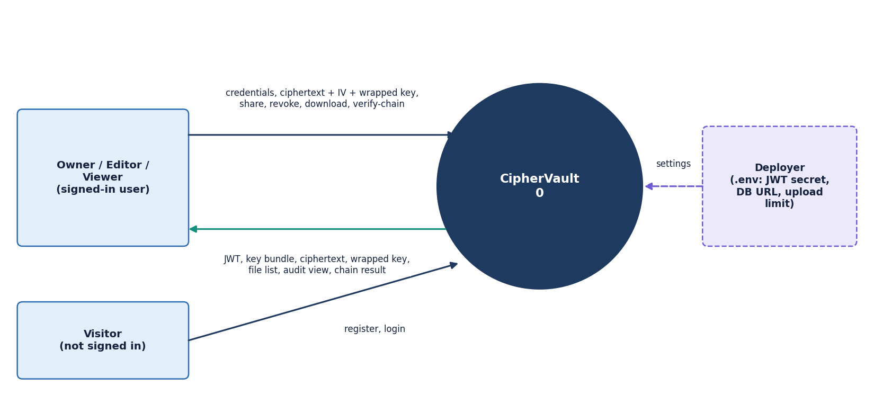
Figure 3: Context diagram (DFD level 0): CipherVault as one process with the signed-in user, the visitor and the deployer.
At level 0 the whole product is a single process. A visitor who is not signed in can only register and log in. A signed-in user, acting as owner, editor or viewer of particular files, sends credentials, ciphertext with its IV and wrapped key, and share, revoke, download and verify-chain requests, and receives the JWT, the sealed key bundle, ciphertext, wrapped keys, file lists, the audit view and the chain result. The deployer is an external source of configuration: the .env file supplies the JWT secret, the database URL, the upload limit and the throttle values to the Settings object. No third-party service appears on the diagram because the product contacts none: there is no cloud storage, key-management service, e-mail or analytics call. The browser-side cryptography is part of the process boundary, since the plaintext and the private key never cross it.

1.3.2 Level 1: five processes
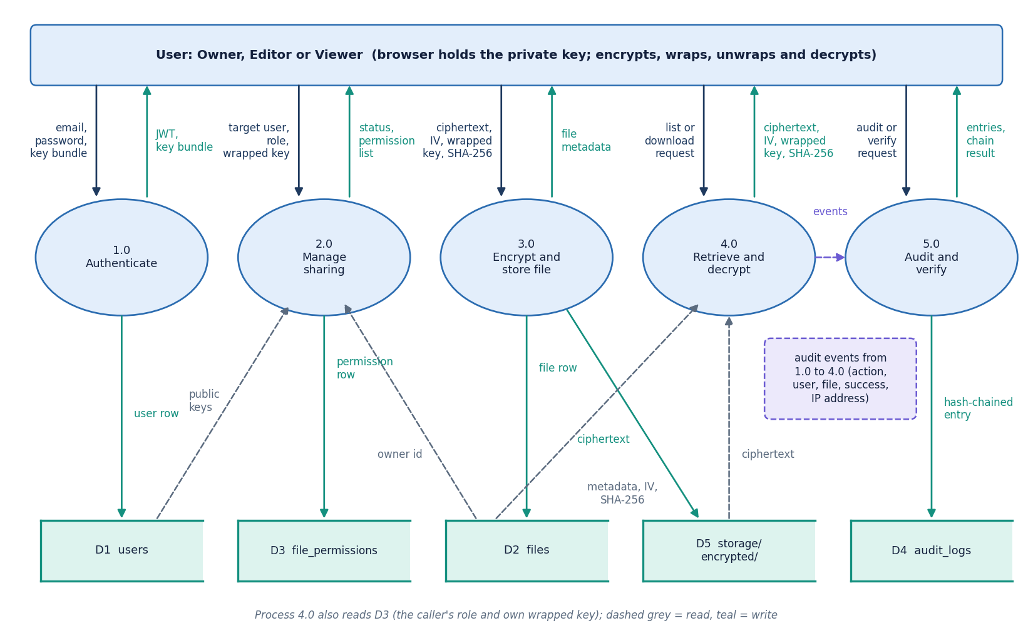
Figure 4: DFD level 1: five processes (authenticate, manage sharing, encrypt and store, retrieve and decrypt, audit and verify) and the stores D1 to D5.
Level 1 splits the product along its routers. Process 1.0 registers users, checks credentials with bcrypt, issues the JWT and hands out the sealed key bundle; it writes the users store (D1). Process 2.0 manages sharing: it reads public keys from D1 and the owner from D2, and writes or deletes permission rows in D3 together with the recipient's wrapped file key. Process 3.0 receives the ciphertext, IV, wrapped key and digest, writes the ciphertext object to the storage directory (D5) and the metadata row to D2. Process 4.0 answers list, metadata and download requests; it reads D2, D3 and D5, checks the caller's role and returns the ciphertext with the caller's own wrapped key. Process 5.0 receives an audit event from each of the other processes, appends it to the hash chain in D4 and answers the audit view and verify requests. Dashed arrows are reads and solid arrows are writes.
The split follows the routers of the application: authentication, sharing, upload, retrieval and audit. Process 5.0 is the only writer of the audit store, and it is called by all the others, which is why in most routes the audit entry is written after the request's main effect has been committed (the delete route records first and then removes the file), so a failure between the two steps can leave an effect without an entry; this is one reason the chain is described as evidence, not proof.

1.3.3 Level 2: encrypt and store a file
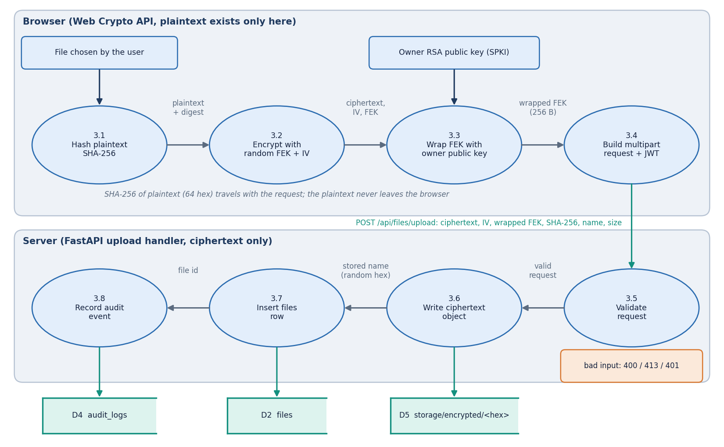
Figure 5: DFD level 2: process 3.0 (encrypt and store file) expanded into four browser sub-processes and four server sub-processes.
Level 2 expands process 3.0, because it carries the central security property of the product. In the browser, process 3.1 computes the SHA-256 digest of the plaintext, 3.2 draws a random file key and IV and encrypts with AES-256-GCM, 3.3 wraps the file key with the owner's RSA public key into a 256-byte value, and 3.4 builds the multipart request with the JWT. On the server, process 3.5 validates the request: authenticated user, base64 fields, an IV that decodes to 12 bytes, a 64-hex digest, and a size within 25 MB (HTTP 413 otherwise). Process 3.6 writes the ciphertext to storage/encrypted under a random 32-hex name, 3.7 inserts the files row with the IV, the wrapped key and the digest, and 3.8 records the upload event in the audit chain. The plaintext exists only in the browser part of the diagram, and the same decomposition applies to replacing file content, which reuses the existing file key.

1.4 UML design

1.4.1 Class diagram
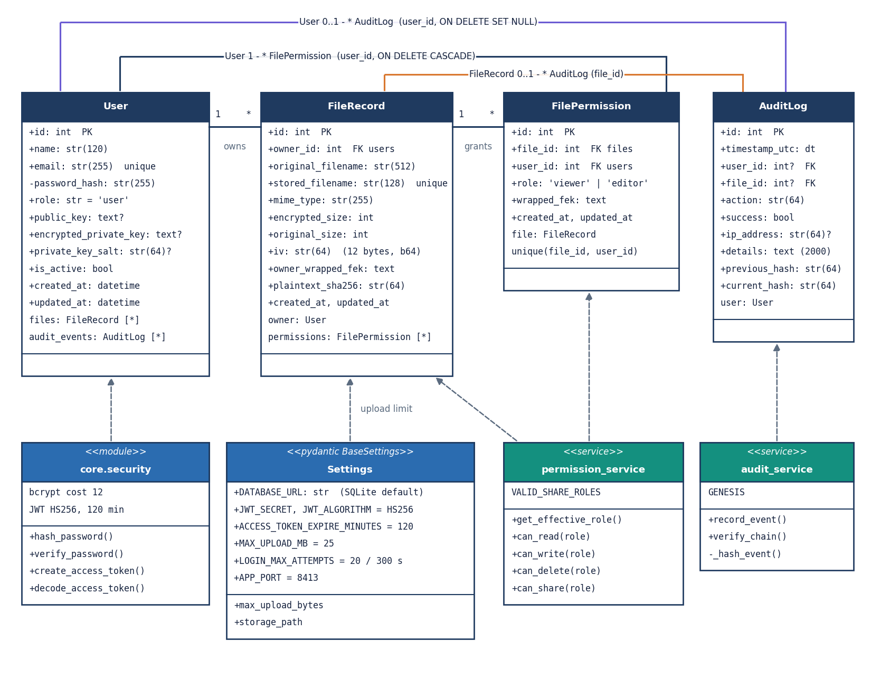
Figure 6: UML class diagram: the four ORM classes (User, FileRecord, FilePermission, AuditLog) and the service and core modules that use them.
The four ORM classes of backend/app/db/models.py carry the data. A User owns zero or more FileRecord objects and receives zero or more FilePermission objects; both relationships delete their children with the parent through the ORM cascade. A FileRecord holds the original and stored file names, the sizes, the IV, the owner's wrapped file key and the plaintext SHA-256, and has many FilePermission rows, each with a role of viewer or editor and the recipient's own wrapped key, unique per file and user. AuditLog rows refer to a user and a file by optional foreign keys declared with ON DELETE SET NULL and carry the previous_hash and current_hash fields. The behaviour is in plain modules rather than classes: permission_service (get_effective_role and the four can_ predicates), audit_service (record_event, verify_chain and the private _hash_event), core.security (bcrypt and JWT functions) and the Settings object, which reads the .env file. The global users.role column exists, but no decision uses it.
The data classes are ordinary SQLAlchemy models, and behaviour lives in two small service modules rather than in the classes. This keeps the access rules in one place (permission_service.py, 35 lines) where they can be read and tested exhaustively, and keeps the hashing rule of the audit chain in one function (_hash_event) shared by the writer and the verifier.

1.4.2 Sequence diagram
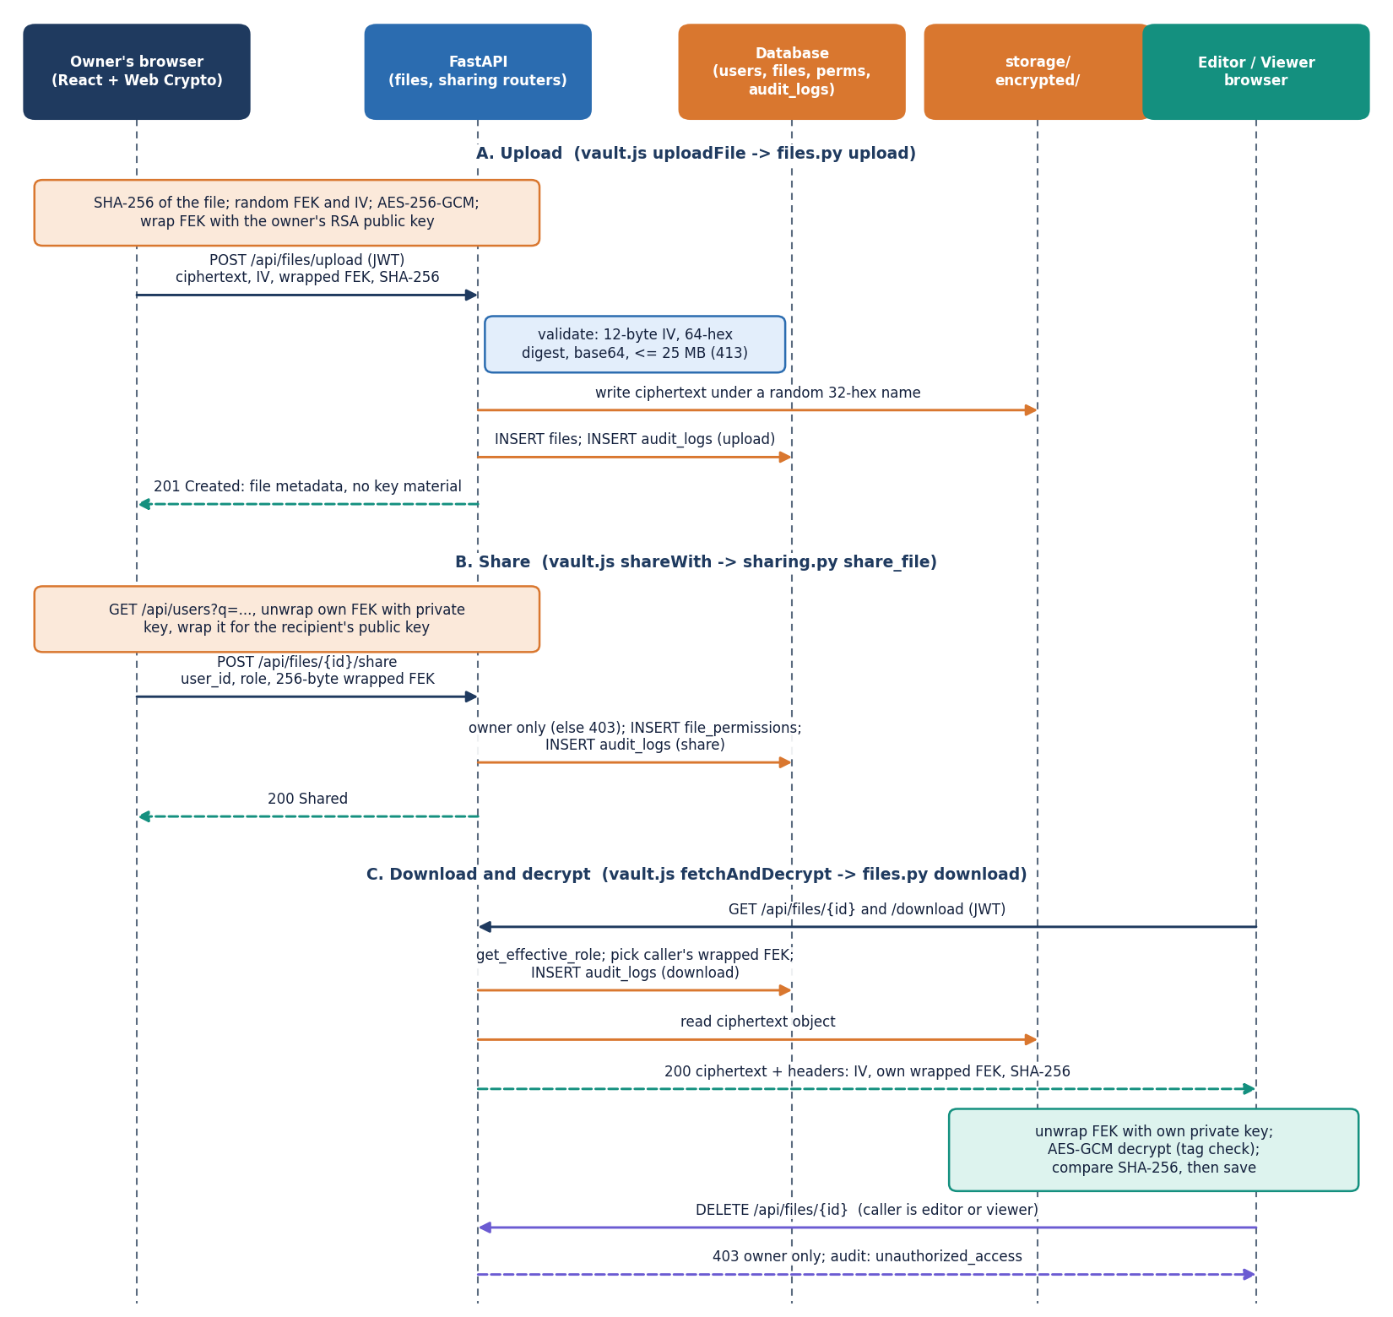
Figure 7: Sequence diagram of the main flow: owner uploads an encrypted file, shares it, and a recipient downloads it; an editor or viewer is refused deletion.
Part A shows the upload. The owner's browser hashes and encrypts the file, wraps the key, and posts the multipart request; FastAPI validates it, writes the ciphertext object, inserts the files row and an audit entry, and answers 201 with metadata that contains no key material. Part B shows sharing. The browser fetches the recipient's public key, unwraps its own copy of the file key, wraps it again for the recipient and posts the 256-byte result with the chosen role; only the owner is accepted (HTTP 403 otherwise) and a file_permissions row is inserted. Part C shows the recipient's download: the role is resolved, the caller's wrapped key is read, the download is audited, and the ciphertext is returned with the IV, wrapped key and digest as headers. The recipient's browser unwraps, decrypts, checks the tag and the SHA-256 and then saves the file. The last pair of messages shows access control at work: a delete request from an editor or viewer is answered with 403 and logged as unauthorized_access.

1.4.3 Use-case diagram
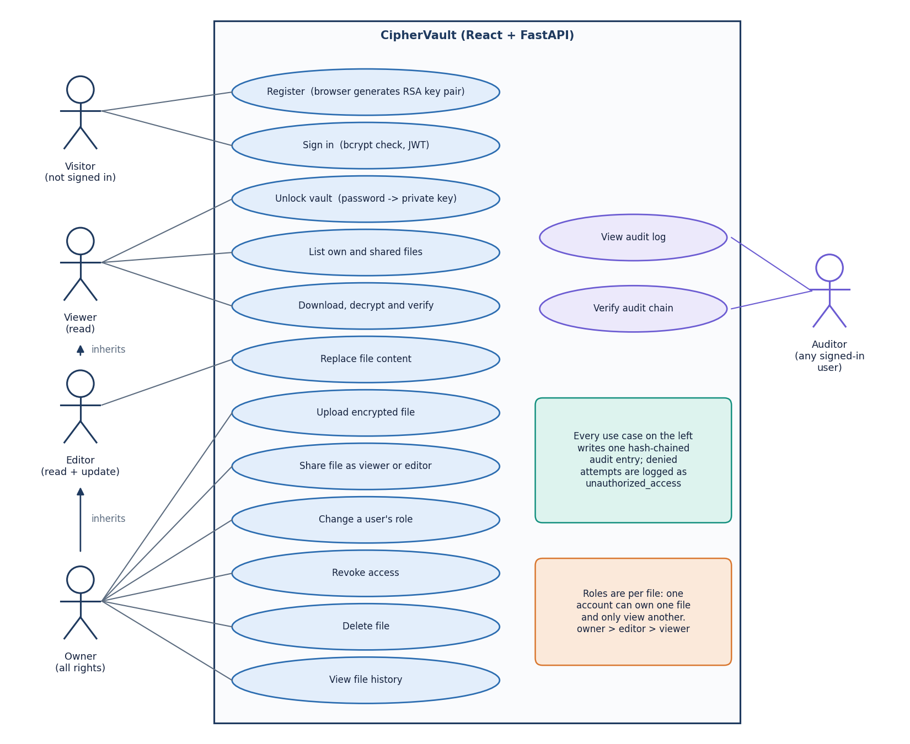
Figure 8: Use-case diagram: visitor, viewer, editor, owner and auditor actors with the twelve file use cases and the two audit use cases.
A visitor can register, which generates the key pair in the browser, and sign in. Roles belong to files rather than to accounts: the viewer can unlock the vault, list files and download and decrypt; the editor inherits that and can also replace file content; the owner inherits both and can upload, share a file as viewer or editor, change a role, revoke access, delete the file and see its history. These rights follow the can_read, can_write, can_delete and can_share predicates of permission_service. The auditor is not a separate role: any signed-in user can view the vault-wide audit log and ask the server to verify the chain, which the limitations chapter records as a weakness. Every use case writes one hash-chained audit entry and a refused attempt is logged as unauthorized_access. There is no administrator role, no multi-factor authentication and no group or organisation concept in this build.

1.5 Database design
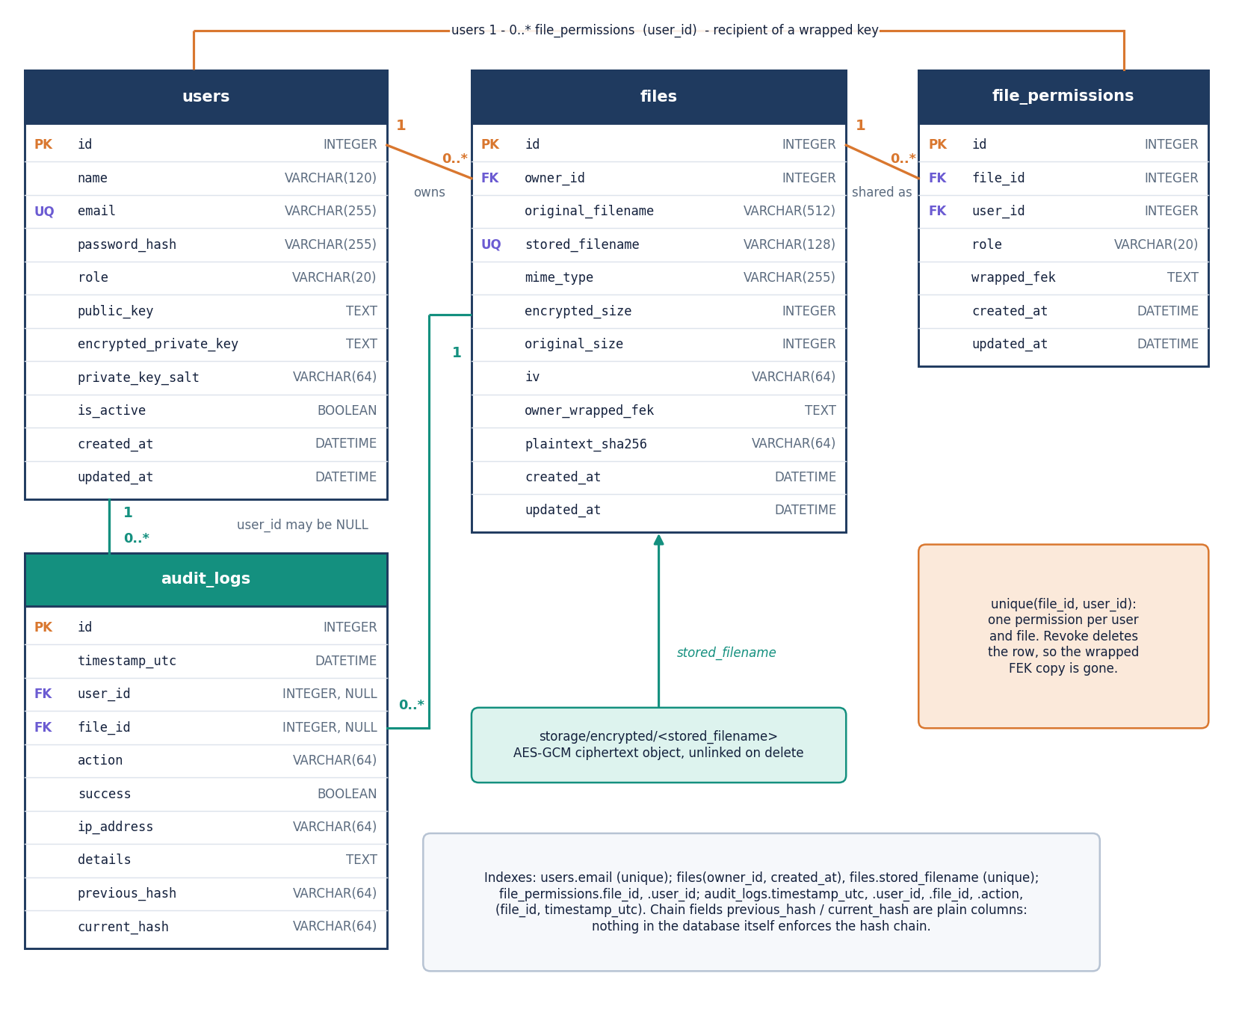
Figure 9: Entity-relationship diagram: users, files, file_permissions and audit_logs, with the ciphertext objects that the files table points to.
The database has four tables created by SQLAlchemy from db/models.py. The users table holds the unique e-mail, the bcrypt hash, the public key, the sealed private-key bundle and its salt. The files table stores the owner as a foreign key, the original and unique stored file names, the MIME type, both sizes, the 12-byte IV in base64, the owner's wrapped file key and the plaintext SHA-256; the ciphertext itself lives in storage/encrypted under the stored name. The file_permissions table links a file and a user with the role and the recipient's wrapped key and has a unique constraint on the pair, so one user holds at most one role per file; revoking deletes the row and with it the server's copy of that key. The audit_logs table keeps the action, outcome, IP address, details and the two hash fields, with optional foreign keys to user and file. The hash chain is a convention of the application code: the database does not enforce it.
Table 2: Tables of the database
Table | Columns | Notes
users | id PK; name; email UNIQUE; password_hash; role (default 'user', unused); public_key (base64 SPKI); encrypted_private_key (JSON bundle); private_key_salt; is_active; created_at; updated_at | One row per account. The server never holds the password or an unsealed private key
files | id PK; owner_id FK users; original_filename; stored_filename UNIQUE (random 32 hex characters); mime_type; encrypted_size; original_size; iv (base64, 12 bytes); owner_wrapped_fek; plaintext_sha256; created_at; updated_at | Metadata and the owner's wrapped key; the ciphertext lives in storage/encrypted. Index on (owner_id, created_at)
file_permissions | id PK; file_id FK files; user_id FK users; role ('viewer' or 'editor'); wrapped_fek; created_at; updated_at | One row per grantee; UNIQUE (file_id, user_id). Deleting the row deletes the grantee's wrapped key
audit_logs | id PK; timestamp_utc; user_id FK users (nullable, SET NULL); file_id FK files (nullable, SET NULL); action; success; ip_address; details (at most 2,000 characters); previous_hash; current_hash | Append-only by convention; indexes on timestamp, user, file, action and (file_id, timestamp_utc)

Four design points deserve mention. Keys are stored only in wrapped form: files.owner_wrapped_fek and file_permissions.wrapped_fek are RSA-OAEP outputs, so a database dump contains no usable file key without the users' private keys. Deleting a file removes its permission rows through the ORM cascade, which removes every grantee's wrapped key together with the file. The audit table keeps nullable foreign keys with ON DELETE SET NULL, so history survives the deletion of a file or a user. Finally, the original file name is stored in clear in the files table (the stored object name is random), because the interface must list files; file names, sizes, MIME types, owners and timestamps are therefore visible to anyone with database access.

1.6 Core algorithm and cryptographic design
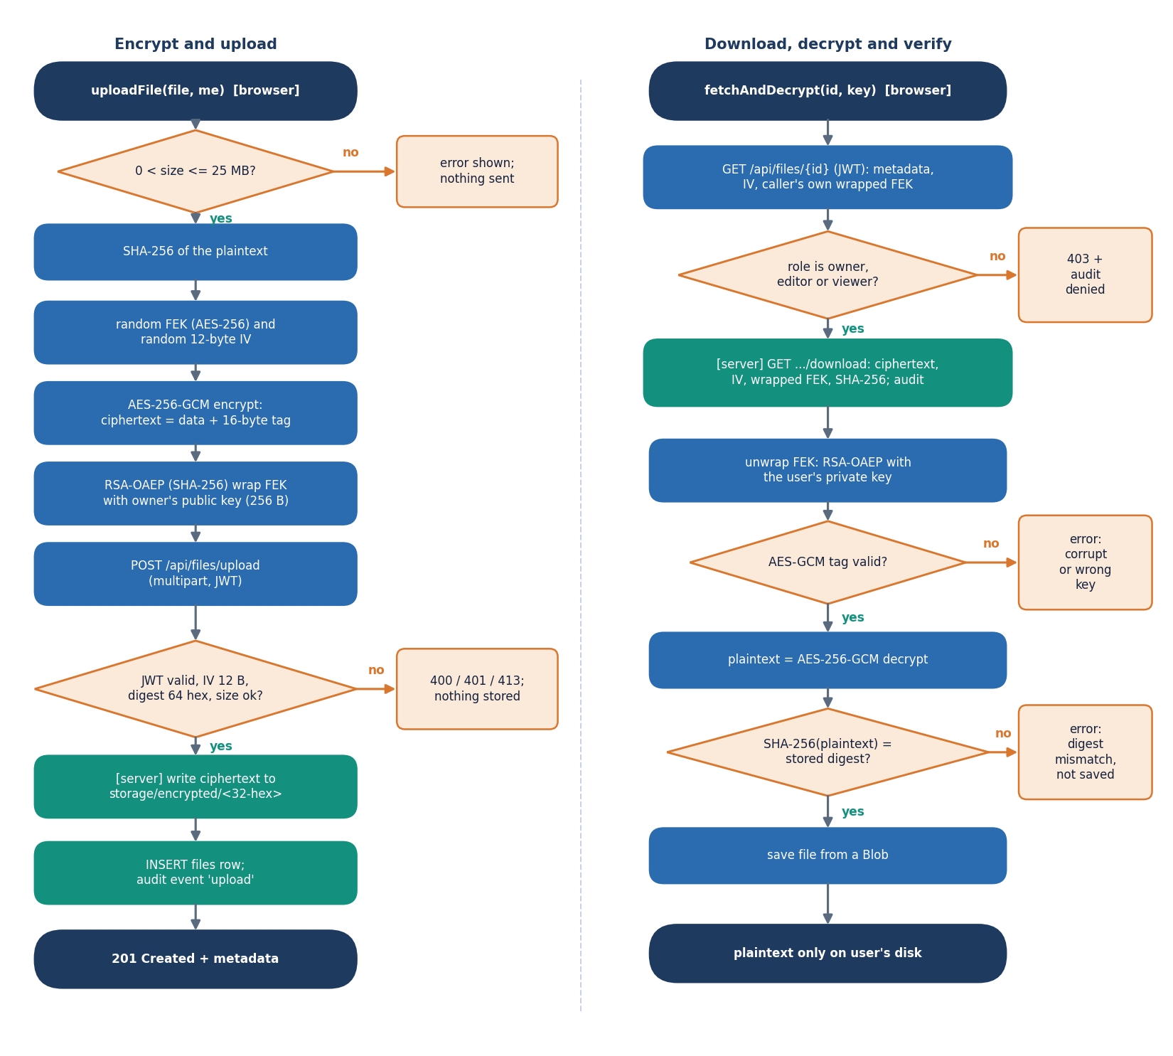
Figure 10: Flowchart of the core algorithm: encrypt and upload on the left, download, decrypt and verify on the right, with every rejection path.
The left column follows uploadFile. The browser rejects an empty file or one above 25 MB, computes the SHA-256 digest, draws a random AES-256 file key and a 12-byte IV, encrypts with AES-256-GCM (the 16-byte tag is appended to the ciphertext), wraps the key with RSA-OAEP and posts the request. The server answers 401 for a bad token, 400 for an invalid IV, digest or base64 value and 413 above the size limit; otherwise it stores the ciphertext, inserts the row and writes the audit event. The right column follows fetchAndDecrypt. The server first resolves the caller's role and answers 403, logged as unauthorized_access, if there is none. The browser unwraps the file key with the private key and decrypts; a failed GCM tag stops the process with an error about a corrupt file or wrong key. Only when the SHA-256 of the plaintext equals the stored digest is the file saved, which gives two independent integrity checks: the authentication tag and the digest.
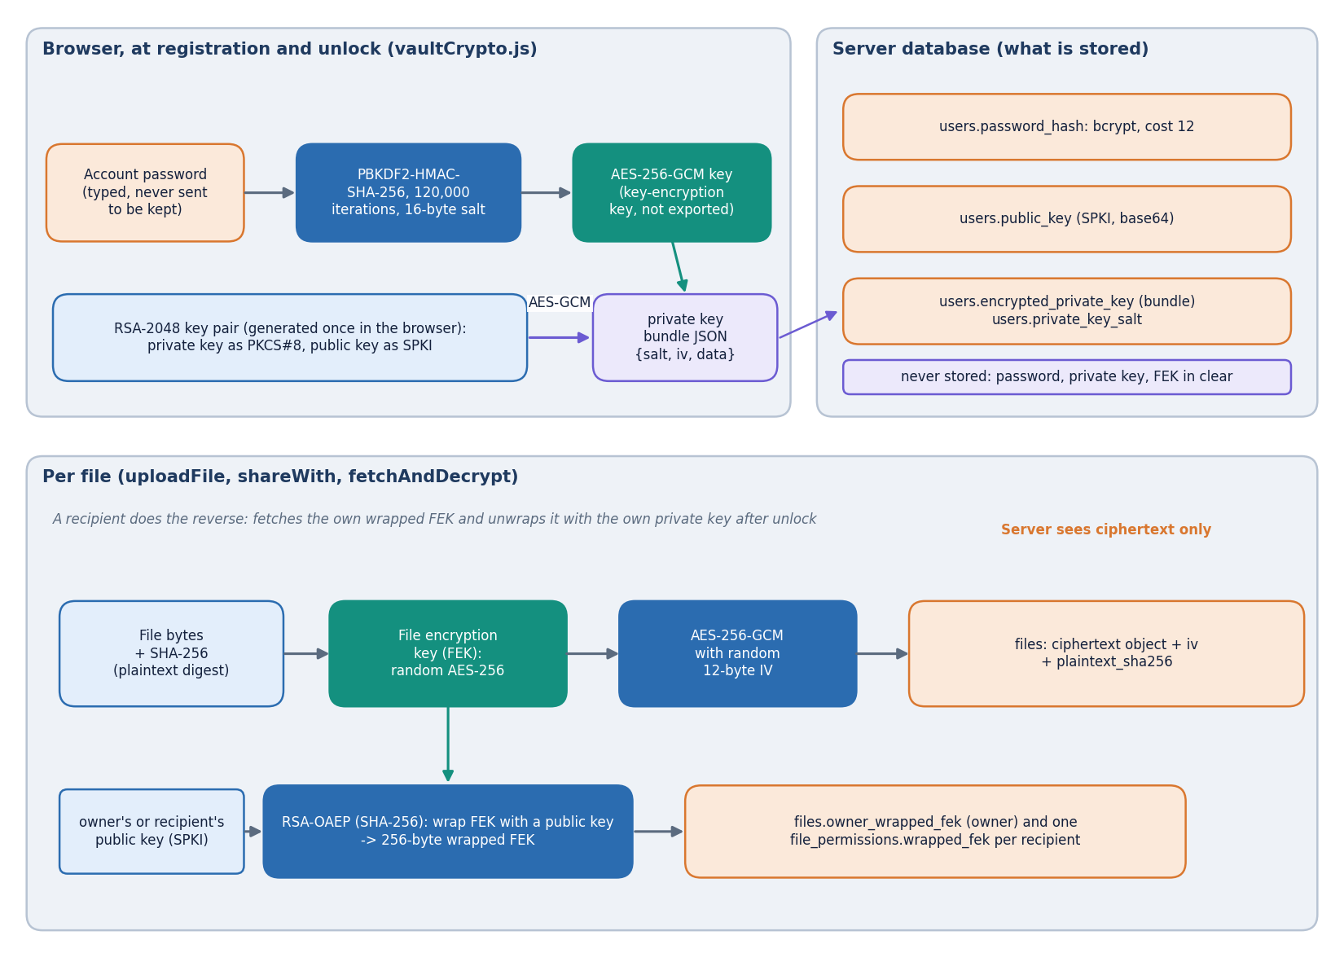
Figure 11: Key hierarchy: password, PBKDF2 key, sealed RSA private key, wrapped per-file keys and what the server stores.
Three layers of keys separate the password from the file data. The password is stretched with PBKDF2-HMAC-SHA-256 (120,000 iterations, 16-byte random salt) into an AES-256-GCM key that is never exported; this key encrypts the PKCS#8 private key, and the JSON bundle with salt, IV, ciphertext and iteration count is stored in the users table. The RSA-2048 public key (SPKI) is stored in clear because senders need it. Each file has its own random AES-256 file key, which encrypts the file with a fresh 12-byte IV and is stored only in wrapped form: RSA-OAEP with SHA-256 turns it into a 256-byte value for the owner (files.owner_wrapped_fek) and one per recipient (file_permissions.wrapped_fek). The login password is checked separately by bcrypt (cost 12) on the server. The server never holds the password, the private key or a file key in clear, which is the property the test suite and the measurements exercise. Losing the password means losing the private key, and therefore the files.
The key hierarchy follows the usual hybrid pattern [14]: a slow password-based step protects the long-term private key, a public-key step distributes per-file keys, and a fast symmetric step protects the data. PBKDF2-HMAC-SHA-256 with 120,000 iterations and a 16-byte random salt derives the sealing key [26], [27]; AES-256-GCM with a fresh 12-byte IV encrypts and authenticates the file [21]; and RSA-OAEP with SHA-256 wraps the 32-byte file key into a 256-byte value [24]. The login password is verified separately with bcrypt at cost 12 [28] and plays no part in the key path. The iteration count is lower than the 310,000 that the closest-architecture paper reports [2] and is a measured trade-off: one derivation took a median of 32.8 ms.
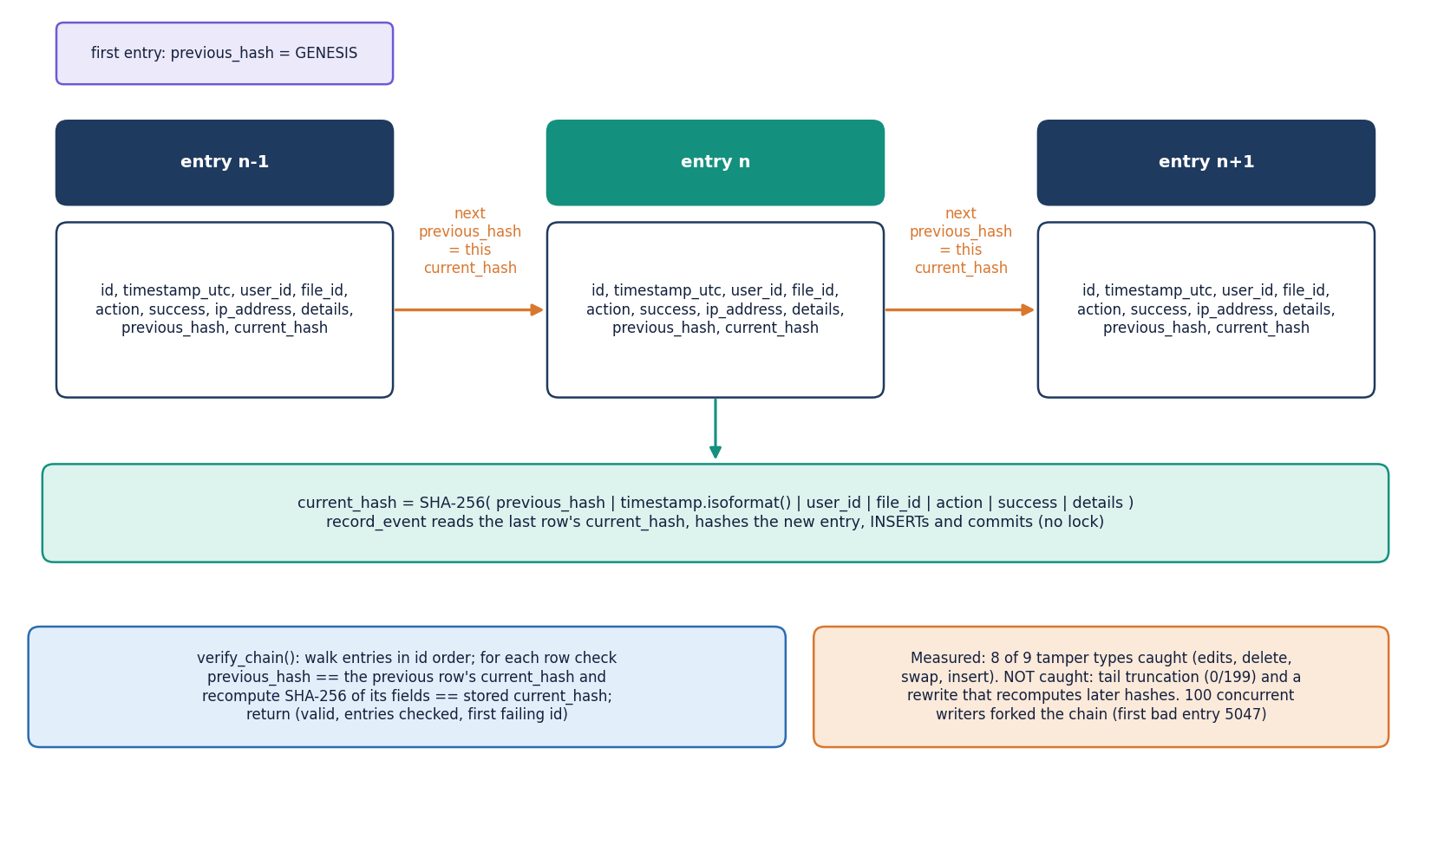
Figure 12: Audit hash chain: each entry stores the previous entry's hash; verify_chain recomputes every hash; the measured weaknesses are noted.
Every security-relevant event becomes an audit_logs row. The service reads the current_hash of the latest row (or the constant GENESIS for the first), hashes the string previous_hash, ISO timestamp, user id, file id, action, success flag and details with SHA-256, and stores the result as the new row's current_hash. verify_chain walks the rows in id order, checks that each previous_hash equals the preceding current_hash and recomputes each hash, returning the first failing id. In the measurements an edit of any field, a deleted middle entry, a swapped pair and an inserted forged entry were detected in every trial. Two weaknesses were also measured and are not hidden: removing entries from the end of the log is not detected (0 of 199), nor is a rewrite that recomputes all later hashes, because the chain has no secret key or external anchor. Concurrent writers can also fork the chain, since record_event reads the last hash and commits without a lock.
The audit design follows the idea of a forward-linked secure log [31], [32] in its simplest form: each entry commits to its predecessor, so changing or removing an entry in the middle breaks every later link. The design stops there. It uses no key and no external anchor, which is why it cannot detect truncation of the newest entries or a complete rewrite, and the service reads the last hash and commits without a lock, which is why concurrent writers fork the chain. These two properties were measured rather than assumed (Chapter 8), and the corresponding improvements are a keyed or signed chain, periodic anchoring outside the database, and a lock or sequence number on the write path.

1.7 Module design
Table 3: Backend modules, sizes and responsibilities
Module | Lines | Responsibility
backend/app/main.py | 90 | Creates the FastAPI application, mounts the five routers, CORS for ports 8413 and 5413, the health and config routes and the single-page-app fallback
backend/app/core/config.py | 37 | Settings read from .env (database URL, JWT secret, token lifetime, upload limit, login throttle)
backend/app/core/security.py | 41 | bcrypt hashing (cost 12) and verification; JWT creation and decoding (HS256)
backend/app/db/database.py | 61 | SQLAlchemy engine, session dependency and table creation for SQLite or PostgreSQL
backend/app/db/models.py | 88 | ORM classes User, FileRecord, FilePermission and AuditLog
backend/app/schemas/schemas.py | 116 | Pydantic request and response models (registration, login, share, role change, audit)
backend/app/api/deps.py | 53 | Current-user dependency (bearer token to user), client address, in-memory login throttle
backend/app/api/auth.py | 103 | Register, login, current user, key update, key bundle, logout
backend/app/api/users.py | 37 | User directory search and public-key lookup used by sharing
backend/app/api/files.py | 279 | Upload, list, shared list, metadata, download, replace content, delete
backend/app/api/sharing.py | 119 | Share, list permissions, change role, revoke (owner only except listing)
backend/app/api/audit.py | 61 | Audit list, per-file history, chain verification
backend/app/services/permission_service.py | 35 | get_effective_role and the predicates can_read, can_write, can_delete, can_share
backend/app/services/audit_service.py | 64 | record_event (append to the hash chain) and verify_chain
tests/ | 371 | 21 pytest tests: auth 6, crypto 5, files 3, rbac 5, audit 2
scripts/ | - | Measurement (measure_metrics.py), end-to-end and browser smoke tests, screenshot capture, demo seeding, evaluation

Table 4: Front-end modules, sizes and responsibilities
Module | Lines | Responsibility
frontend/src/lib/vaultCrypto.js | 108 | Web Crypto wrappers: key pairs, PBKDF2 key sealing, AES-256-GCM file encryption, RSA-OAEP key wrapping, SHA-256
frontend/src/lib/vault.js | 87 | Upload, replace, fetch-and-decrypt and share, combining the API with the crypto module
frontend/src/lib/api.js | 94 | Fetch client, bearer token in sessionStorage, error type, one function per endpoint
frontend/src/lib/auth.jsx | 90 | Authentication context: login, registration with key generation, unlock, lock, logout
frontend/src/features/UnlockGate.jsx | 95 | Unlock dialog that every key-needing action can await
frontend/src/features/ShareModal.jsx | 170 | Share, change role and revoke dialog
frontend/src/features/useFileActions.jsx | 114 | Upload, download, replace and delete actions with progress and error messages
frontend/src/features/VerifyChain.jsx | 55 | Audit chain verification control
frontend/src/pages/ (8 pages) | 1,341 | Landing, Auth (sign-in and register), Dashboard, Files (owned and shared), FileDetail, Audit, Security, NotFound
frontend/src/components/ | 1,610 | In-house UI kit, charts, motion helpers and the three.js landing scene
frontend/src/styles/ | 2,665 | Design tokens, base, component and landing styles

In total the backend has 1,184 lines in 20 Python files, the tests 371 lines in 7 files and the front end 6,831 lines in 39 source files. The routers are thin: they validate input, call the permission service, write the file or row, and record an audit event. All cryptography on file contents is in vaultCrypto.js, which is the only module that calls crypto.subtle; the other front-end modules pass it buffers and keys. This separation is what allows the server-side tests to treat the ciphertext as opaque bytes and the browser tests to exercise the same functions the interface uses.

1.8 API design
The API is a JSON and multipart REST interface under /api. There are 24 endpoints; all except the four public ones (health, config, register and login) require a bearer token, and every file operation additionally resolves the caller's effective role on the file. File content travels as multipart form data (ciphertext plus text fields), and the download returns the ciphertext as application/octet-stream with the IV, the caller's wrapped key, the digest, the file name and the MIME type in X-CipherVault-* response headers, which the CORS configuration exposes to the browser.
Table 5: The 24 endpoints of the CipherVault API
Method | Path | Access | Purpose | Errors
GET | /api/health | - | Liveness: status and application name | -
GET | /api/config | - | Application name and upload limit (25 MB) for the interface | -
POST | /api/auth/register | - | Create the account with the public key and the sealed private-key bundle; bcrypt hash of the password | 400 duplicate e-mail; 422 invalid fields
POST | /api/auth/login | - | Check the password and return a JWT (120 min); throttled | 401 wrong credentials; 429 throttle
GET | /api/auth/me | JWT | The signed-in user (never the password hash) | 401
PUT | /api/auth/keys | JWT | Replace the public key and the sealed private-key bundle | 401; 422
GET | /api/auth/key-bundle | JWT | The caller's own sealed private-key bundle | 404 none stored
POST | /api/auth/logout | JWT | Write the logout event (the token itself is not revoked) | 401
GET | /api/users?q= | JWT | Search active users by name or e-mail (at most 50) | 401
GET | /api/users/{id}/public-key | JWT | Public key of one user, used to wrap a file key for them | 404
POST | /api/files/upload | JWT | Multipart upload of ciphertext, IV, wrapped key, digest and metadata; stores the object under a random name | 400 empty, bad IV, digest or name; 413 over 25 MB
GET | /api/files | JWT | Files the caller owns, newest first | 401
GET | /api/files/shared | JWT | Files shared with the caller, with the effective role | 401
GET | /api/files/{id} | Any role | Metadata, IV and the caller's own wrapped key | 403 no role (logged); 404
GET | /api/files/{id}/download | Any role | Ciphertext with IV, wrapped key and digest in headers; writes a download event | 403 (logged); 404 missing object
PUT | /api/files/{id} | Owner, Editor | Replace the ciphertext, IV and digest; the owner may also replace the wrapped key | 403 (logged); 400; 413
DELETE | /api/files/{id} | Owner | Delete the ciphertext object and the rows | 403 (logged); 404
POST | /api/files/{id}/share | Owner | Grant Viewer or Editor with the recipient's wrapped key (must be 256 bytes) | 403; 404 user; 400 invalid; 409 already shared
GET | /api/files/{id}/permissions | Any role | Owner and every grantee with role | 403 (logged); 404
PUT | /api/files/{id}/permissions/{uid} | Owner | Change a grantee's role to viewer or editor | 403; 404
DELETE | /api/files/{id}/permissions/{uid} | Owner | Revoke: delete the grant and the stored wrapped key | 403; 404
GET | /api/audit?limit= | JWT | Newest audit entries (limit up to 500), optionally filtered by action | 422 limit above 500
GET | /api/audit/file/{id} | Owner | Audit history of one file | 403 not owner
GET | /api/audit/verify | JWT | Recompute the chain; returns validity, count and first failing id; logs the verification | 401

Error behaviour is part of the design. A caller without a role on a file receives HTTP 403, not 404, for an existing file, and the refusal is logged as unauthorized_access; a request for a file id that does not exist receives 404. Responses never contain key material other than the caller's own wrapped key, the caller's own sealed private-key bundle and the public keys that sharing needs. Validation is strict where the server can check it without decrypting: the IV must decode to 12 bytes, the digest must be 64 hexadecimal characters, a wrapped key accepted by the share route must decode to exactly 256 bytes, and the ciphertext may not exceed the size limit.

1.9 User interface design
The interface is a React single-page application with a dark and a light theme (the saved choice, otherwise the system preference), reduced-motion support and layouts that were checked down to 360 px. Its structure mirrors the security model: the sidebar offers the dashboard, the user's own files, the files shared with the user, the audit log and the security profile, and a status chip at the top of every page shows whether the vault is unlocked. If an action needs the private key while the vault is locked, the unlock dialog opens and the action resumes after the password is accepted.
Table 6: Pages of the web application
Page | Route | Endpoints used | Purpose
Landing | / | GET /api/health, /api/config | Product page with the three.js hero scene and the security model
Sign in / Register | /login, /register | POST /api/auth/login, /api/auth/register; GET /api/auth/key-bundle, /me | Key generation at registration, vault unlock at sign-in, one-click demo accounts
Dashboard | /app | GET /api/files, /api/files/shared, /api/audit | Counters, security events per day, access by role, recent activity, security status
My files, Shared with me | /app/files, /app/shared | GET /api/files, /api/files/shared, /api/config | Drop-zone upload with progress, file table with role badges
File detail | /app/files/:id | GET /api/files/{id}, /permissions, /audit/file/{id}; download, replace, delete, share | Details, access list, history, decrypt and download
Audit log | /app/audit | GET /api/audit, /api/audit/verify | Filterable event table and chain verification
Security | /app/security | (client state) | Account details, key status, lock and sign out

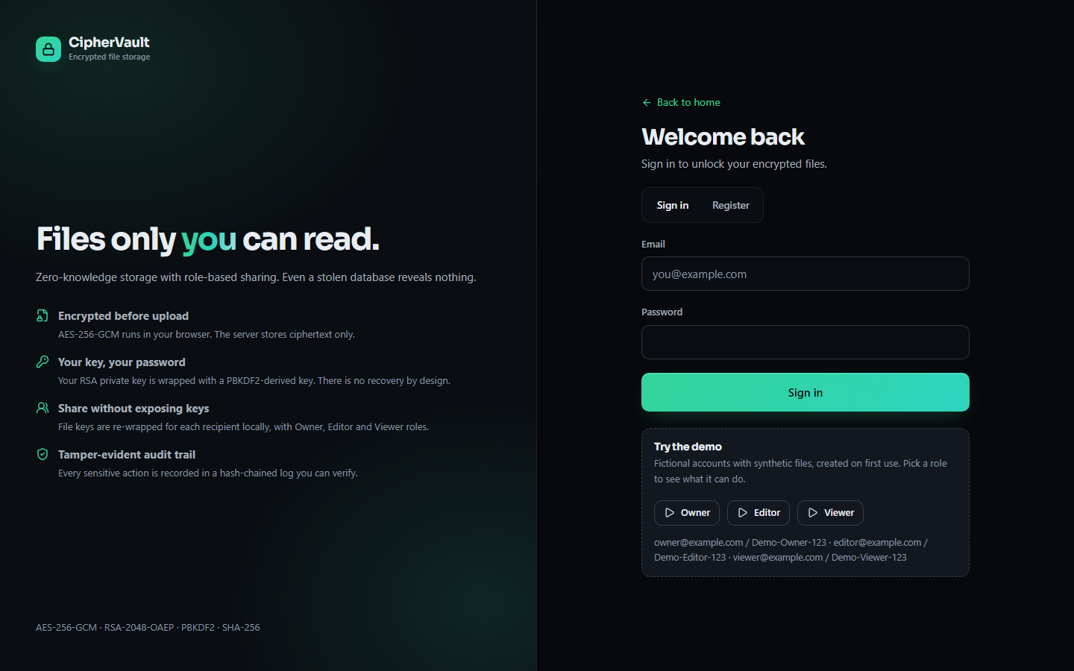
Figure 13: Sign-in page of CipherVault (1440 x 900): the password both authenticates the user and unlocks the private key.
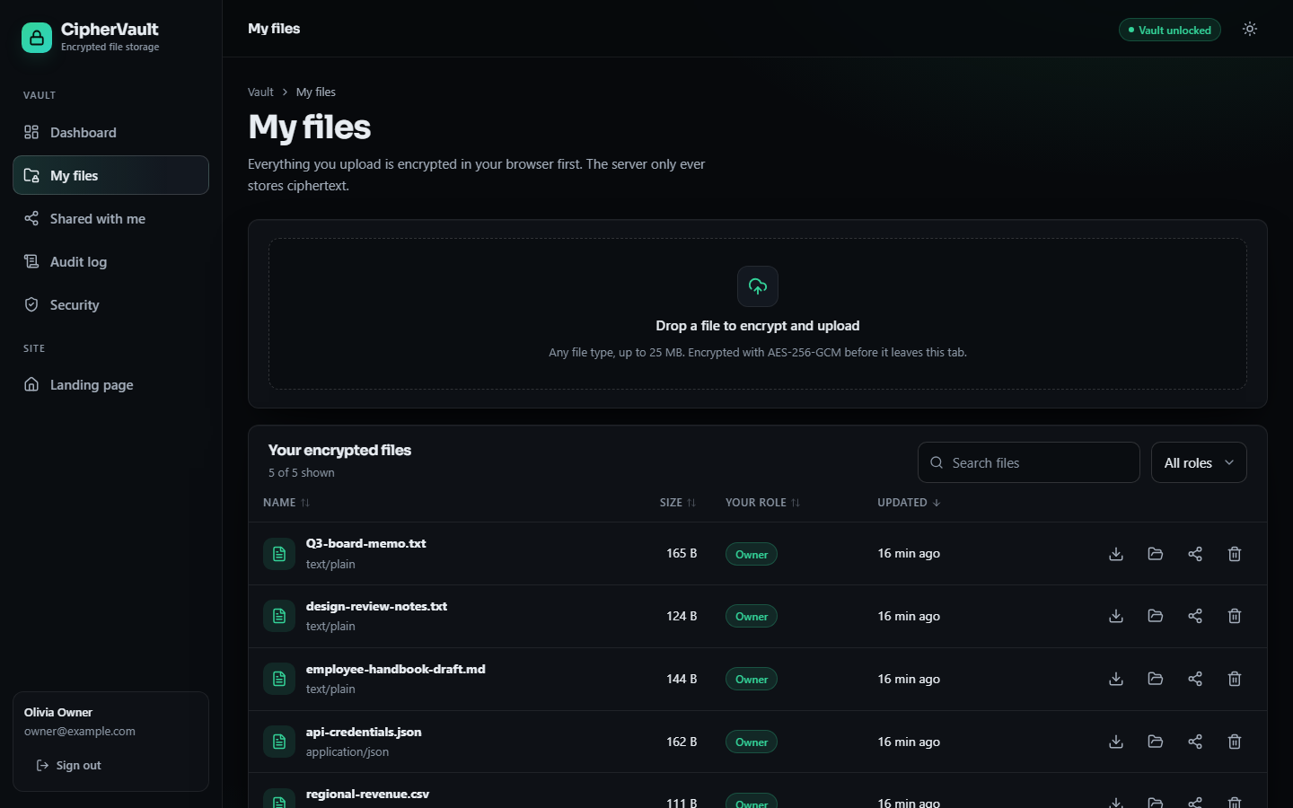
Figure 14: The My files page with synthetic demo files, role badges and the encrypted-upload drop zone.
Design choices in the interface follow the security model. Role badges and the access list make the effective role visible before an action is attempted; destructive actions (delete, revoke) ask for confirmation; error messages say what failed (for example that the AES-GCM tag or the SHA-256 digest did not verify) without suggesting that a corrupt file was saved; and the demo-login buttons create three fictional accounts (owner, editor and viewer at example.com) with synthetic files so that the role rules can be seen without real data.

1.10 Design decisions and trade-offs
The table below records the principal decisions with the alternative that was not taken, the reason, and the cost that the decision brought. The costs are the same limitations that Chapters 8 and 9 report from measurement.
Table 7: Principal design decisions
Decision | Alternative | Reason | Cost
Encrypt in the browser, not on the server | Server-side encryption with a master key | The server then holds no key that opens a file | Password loss means data loss; the delivered JavaScript is trusted
One random AES-256-GCM key per file, wrapped per recipient | One key per user, or proxy re-encryption | Sharing re-wraps 32 bytes instead of re-encrypting the file; revocation deletes one row | No re-keying on revoke; downloaded keys cannot be recalled
RSA-2048-OAEP with SHA-256 for key wrapping | Elliptic-curve or hybrid key encapsulation | Natively supported by Web Crypto in every current browser; 256-byte outputs are easy to validate | Larger keys and slower key generation than curves
Password-sealed private key stored on the server | Key kept only on the device, or hardware token | The same account works from any browser; the server stores only a sealed bundle | Offline guessing of a weak password is limited only by PBKDF2 (120,000 iterations)
Roles per file (Owner, Editor, Viewer) | Account-wide roles or attribute policies | Matches how files are shared; three roles are easy to verify exhaustively | No groups, no inheritance, no administrator
Hash-chained audit log in the same database | Signed log shipped to external storage | Needs no extra service and makes edits, deletions and insertions detectable | No secret key or anchor: tail truncation and a full rewrite are not detected
Whole-file encryption with a 25 MB limit | Chunked streaming encryption | A single GCM operation is simple and has one tag and one IV to check | Memory use grows with file size; no resumable upload
SQLite by default, PostgreSQL by configuration | PostgreSQL only | Zero-setup local deployment | Single-writer assumptions in the audit service; PostgreSQL path untested

Every design has costs, and this one is no exception. The strongest property of CipherVault, that the server cannot read files, is also the source of its two hardest user-facing limits: a lost password cannot be recovered, and revocation cannot undo what a recipient already holds. The comparison with the base paper [1] is therefore one of different trade-offs, not of a better scheme: attribute-based encryption gives policy-based access without a per-recipient key list, at the price of heavier infrastructure, while CipherVault accepts a per-recipient wrapped key to keep the system small and measurable.

2. IMPLEMENTATION

2.1 Application architecture
The product is one FastAPI service (backend/app/main.py, port 8413) and one React 19 application built with Vite (port 5413 in development, served by the same service after npm run build). The backend has 1,184 lines in 20 Python files, the tests 371 lines in 7 files, the browser application 6,831 lines in 39 files and the scripts 1,470 lines in 6 files. The service follows one rule: a route does HTTP work and calls a service function for the decision. It validates the request with Pydantic and explicit checks, asks permission_service for the caller's role, performs the database and filesystem work through a per-request SQLAlchemy session, and records the outcome with audit_service.
Figure 15: Layered architecture of CipherVault: the browser as the cryptographic endpoint, the FastAPI application with 24 endpoints, the service and core layer, and the database and ciphertext store.
The two service modules are small enough to quote. The role lookup and the four predicates of permission_service.py are the entire access-control logic of the system:
def get_effective_role(db, file, user_id):
if file.owner_id == user_id:
return "owner"
perm = (db.query(FilePermission)
.filter(FilePermission.file_id == file.id, FilePermission.user_id == user_id)
.first())
return perm.role if perm else None

def can_read(role): return role in ("owner", "editor", "viewer")
def can_write(role): return role in ("owner", "editor")
def can_delete(role): return role == "owner"
def can_share(role): return role == "owner"

The audit service reads the last hash, derives the new one and commits the entry. It reads and writes in two separate steps without a lock, which is correct for one writer at a time and is the cause of the concurrency defect measured in Chapter 7:
def record_event(db, *, action, success=True, user_id=None, file_id=None, details="", ip_address=None):
last = db.query(AuditLog).order_by(AuditLog.id.desc()).first()
previous_hash = last.current_hash if last else GENESIS
now = datetime.now(timezone.utc)
current_hash = _hash_event(previous_hash, now, user_id, file_id, action, success, details)
entry = AuditLog(timestamp_utc=now, user_id=user_id, file_id=file_id, action=action,
success=success, ip_address=ip_address, details=details[:2000],
previous_hash=previous_hash, current_hash=current_hash)
db.add(entry)
db.commit()
return entry

In the browser, the code is organised in three layers. lib/vaultCrypto.js is the only file that calls Web Crypto; lib/vault.js combines it with the API calls (uploadFile, replaceFileContent, fetchAndDecrypt, shareWith); and lib/auth.jsx and features/UnlockGate.jsx hold the session and the in-memory private key. A single fetch wrapper in lib/api.js attaches the bearer token, turns the detail field of an error response into the error message, and signs the user out on a 401. The pages (Landing, Auth, Dashboard, Files, FileDetail, Audit, Security, NotFound) call these functions and render the results; no page calls Web Crypto directly. The JWT is kept in sessionStorage, which is cleared when the tab closes, and the unlocked private key is kept only in React state, so a reload locks the vault and the next action that needs the key asks for the password again.

2.2 API design
The 24 endpoints are listed in Chapter 5. This section shows the shape of the two exchanges that carry the security design. Both are plain HTTP: the upload is a multipart form with a binary part, and the download returns the binary body with the cryptographic parameters in response headers, so that the ciphertext never has to be wrapped in JSON or base64.
POST /api/files/upload Authorization: Bearer <JWT>
multipart/form-data
ciphertext (binary, application/octet-stream)
original_filename "Q3-board-memo.txt" mime_type "text/plain" original_size 217
iv base64, 12 bytes plaintext_sha256 64 hex digits
wrapped_fek base64, 256 bytes (RSA-OAEP under the owner's public key)

201 Created {"id", "original_filename", "mime_type", "encrypted_size", "original_size",
"owner_id", "owner_name", "effective_role": "owner", "plaintext_sha256", ...}

GET /api/files/{id}/download Authorization: Bearer <JWT>
200 OK body = ciphertext (application/octet-stream)
X-CipherVault-IV, X-CipherVault-Wrapped-FEK (the caller's own copy),
X-CipherVault-SHA256, X-CipherVault-Filename, X-CipherVault-MIME
403 Forbidden {"detail": "Access denied"} (and an unauthorized_access audit entry)

Three properties of this design are worth stating. The upload response carries no key material and no iv; they are returned only by GET /api/files/{id}, which attaches the wrapped key that belongs to the caller (the owner's or the recipient's). Every 403 caused by a missing role writes an unauthorized_access entry to the audit chain, so a refused attempt is itself evidence. And PUT /api/files/{id} replaces the content of an existing file: the browser unwraps the existing file key, encrypts the new content under it with a fresh IV and uploads, so every share keeps working without re-wrapping.
Measured behaviour (127.0.0.1, medians; the host was shared with other jobs). The health route answers in 1.68 ms and GET /api/auth/me in 6.32 ms; listing 65 owned files takes 40.3 ms. Login is dominated by bcrypt at cost 12: 308 ms for a correct password and 326 ms for a wrong one. A 1 MiB ciphertext uploads in 44.5 ms and downloads in 22.4 ms; a 10 MiB one in 139 ms and 102 ms; the largest object (just under 25 MiB) in 288 ms and 177 ms. Sharing takes 37.8 ms, a role change 22.7 ms and a revocation 24.7 ms (one run each); the first download after the revocation was refused with HTTP 403. Writing one audit event takes a median of 19.0 ms (95th percentile 90.0 ms).
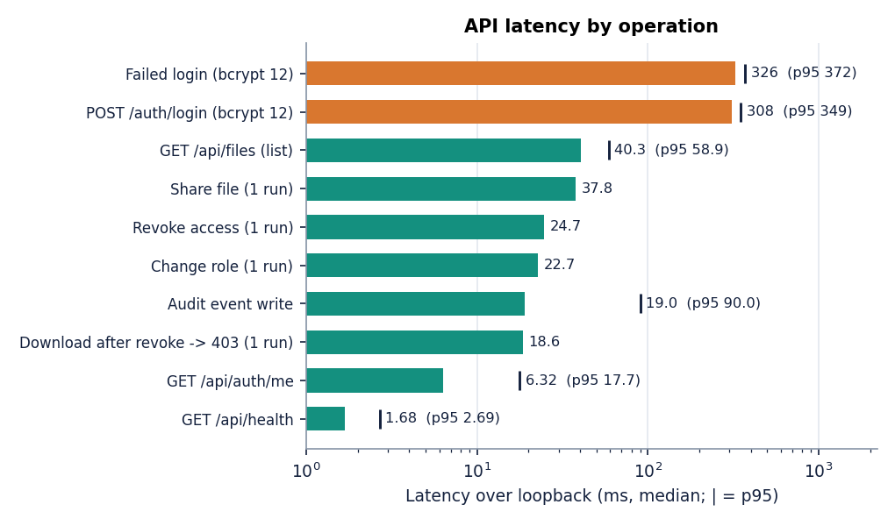
Figure 16: Median API latency over loopback (marker = 95th percentile where several runs exist).
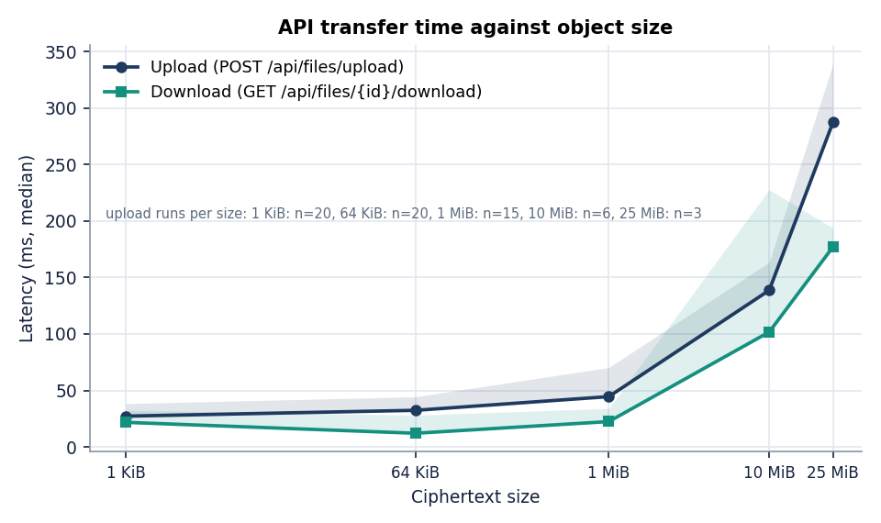
Figure 17: Upload and download of ciphertext through the API against object size.

2.3 Security and error handling
The security model is stated first as a list of what each mechanism provides and then as a list of what it does not provide, so that no reader assumes more than the system delivers.

2.3.1 What is implemented
• Client-side encryption. The server stores AES-256-GCM ciphertext only. Opening the stored objects, a database dump or a backup yields no plaintext and no usable key.
• Authentication. Passwords are checked against bcrypt hashes; a wrong e-mail or password gives the same message (Invalid email or password) and a login_failure entry. Tokens are signed with HS256 and expire after 120 minutes; a missing, malformed, expired or wrongly signed token is refused with HTTP 401 and a user who is deactivated or deleted is refused too.
• Authorisation on every file route. Each route resolves the effective role on the server and refuses with HTTP 403 when the predicate fails; the client's idea of the role is never trusted. Refusals are audited.
• Input validation. Pydantic enforces names (1 to 120 characters), e-mail syntax, passwords (8 to 128 characters), roles (viewer or editor only) and non-empty key fields (HTTP 422); the file routes enforce the structural rules of Section 6.3.2 (HTTP 400 and 413).
• Storage safety. Stored names are random, so path traversal through a file name is not possible; SQL goes through the ORM, so values are parameterised; deleting a file removes the object and its rows and records a delete event.
• Login throttling. Twenty attempts per five minutes per IP address and e-mail, counted in memory, then HTTP 429.
• Browser side. The application renders file names and details as React text, uses no raw HTML insertion, locks the vault on reload and on request, and shows a decryption or integrity failure as an error without saving the file.

2.3.2 What is not provided
• No protection against an active malicious server. The server delivers the JavaScript that performs the encryption and receives the password at login; a modified server could capture either. This is the trust problem of every web-delivered end-to-end design, and attacks of this kind on a deployed encrypted store are documented in the literature [8].
• Revocation is forward-only. Revoking a user deletes the server-side wrapped key and refuses further downloads, but a user who already downloaded the ciphertext and unwrapped the key keeps both; the file is not re-encrypted under a new key.
• Audit trail limits. Any signed-in user can read the vault-wide event list; tail truncation and a complete re-hash are not detected; concurrent writers fork the chain (Chapter 7). The client IP address is taken from the X-Forwarded-For header when present, so behind no proxy it can be spoofed, which also weakens the throttle.
• Metadata is public to the server. File names, sizes, types, owners and times are stored in clear, the user list is searchable by any signed-in user, and the registration route confirms whether an e-mail address is registered.
• Accounts. No multi-factor authentication, no password reset (a lost password means lost data, because the private key cannot be unsealed), no account lockout other than the in-memory throttle that a restart clears, and a placeholder JWT secret that the deployer must change.
• Size. Whole-file encryption in memory limits files to 25 MB; there is no chunking, streaming or resumable upload.
Table 8: HTTP status codes returned by the API and their causes (from the code).
Status | Raised when
400 | Invalid base64, IV length other than 12 bytes, malformed digest, invalid file name or size; duplicate e-mail at registration; sharing with the owner
401 | Missing, malformed, expired or wrongly signed token; unknown or deactivated user; wrong credentials
403 | The effective role does not allow the operation (read, update, delete, share, change role, revoke, file history)
404 | File, share target, permission row or stored object not found; deleted file
409 | The recipient already has access (use the change-role route)
413 | Ciphertext larger than 25 MB plus 1 KiB (measured: HTTP 413 for a 25 MB object plus 5,000 bytes)
422 | Request body violates the schema (e-mail syntax, name or password length, role other than viewer or editor)
429 | More than 20 login attempts in 300 seconds for one IP address and e-mail
500 | The filesystem refused a write or a delete

The automated tests cover the registration and login rules, the missing and invalid token cases, the owner, editor, viewer and stranger decisions, the share, change-role and revoke operations, the malformed upload and the audit tamper check (21 tests); the 429 response, the 409 response and the 500 responses were not exercised by any test (Chapter 7).

2.4 Installation and execution
The project guide (HOW_TO_RUN.md) asks for Python 3.11 or newer, Node.js 20 or newer, a current browser with Web Crypto support and about 500 MB of disk space. requirements.txt lists fastapi, uvicorn, sqlalchemy, psycopg, alembic, pydantic, pydantic-settings, email-validator, PyJWT, bcrypt, python-multipart, cryptography, python-dotenv, pytest, httpx and fpdf2 with minimum versions and no upper pins; the front end depends on React 19, Vite 8, React Router 7, Recharts, three.js, Framer Motion, GSAP and Lenis. The measurements in this report used Python 3.11.9 and Chrome 155.0.8059.85 on Windows 11.
1. Open the project folder 8.ProjectCode. Copy .env.example to .env and replace JWT_SECRET by a long random string (the file is excluded from version control).
2. Double-click run.bat. It checks Python and Node, creates .venv, installs requirements.txt and, on the first run, npm install in frontend/, then starts the API with python -m uvicorn backend.app.main:app --host 127.0.0.1 --port 8413 and the Vite server on port 5413 in two windows.
3. Open http://localhost:5413. Choose Try the demo for a populated vault with the three demonstration roles, or register an account, which creates the key pair in the browser, and upload a file.
4. Run python -m pytest for the automated tests (21 passed in 13 s here). python scripts/e2e_check.py --url http://localhost:8413 runs the API end-to-end check against a running server, and python scripts/smoke_test.py adds a Playwright walk of the interface.
5. For the production-style variant, docker compose build and docker compose up start PostgreSQL 16 and the application, which serves the built front end on http://localhost:8413; the port is published to 127.0.0.1 only. This route was not run during the documentation work.
Three notes come from this project's own runs. The database is created at start-up from the SQLAlchemy models (init_db), and there is no migration: alembic is a dependency but no migration scripts exist, so a change of schema needs a new database. The measurements used a scratch database, a scratch ciphertext folder and a throttle limit raised to 100,000 attempts, so that the login timings were not disturbed by the throttle; the shipped limit of 20 was not exercised. To reproduce the numbers, run python scripts/measure_metrics.py with the browser available (it starts its own server on a scratch database) and python scripts/evaluate.py; Appendix B repeats the instructions as a user guide with the screens.

3. KEY CODE WALK-THROUGHS

3.1 Browser-side encryption and key wrapping (`vault.js`, `vaultCrypto.js`)
Upload is the one place where plaintext exists, and it exists only in the browser. The file is read into memory, its SHA-256 is computed, a fresh 256-bit AES-GCM key (the file encryption key, FEK) is generated, the file is encrypted with a new random 12-byte IV, and the FEK is wrapped with the owner's RSA-2048 public key using OAEP. Only the ciphertext, the IV, the wrapped key and the hash are placed in the multipart form; the unwrapped key is never sent. AES-GCM appends a 16-byte authentication tag, which is the whole of the 16-byte size overhead measured in Chapter 8.
export async function uploadFile(file, me, onStage = () => {}) {
const cfg = await api.config()
if (file.size > cfg.max_upload_mb * 1024 * 1024) throw new Error(`${file.name} exceeds the ${cfg.max_upload_mb} MB limit.`)
if (file.size === 0) throw new Error(`${file.name} is empty.`)
onStage('Encrypting in your browser')
const buf = await file.arrayBuffer()
const sha = await C.calculateSHA256(buf)
const fek = await C.generateFileEncryptionKey()
const enc = await C.encryptFile(buf, fek)
const wrapped = await C.wrapFileKey(fek, await C.importPublicKey(me.public_key))
const form = new FormData()
form.append('ciphertext', new Blob([enc.ciphertext], { type: 'application/octet-stream' }), 'ciphertext.bin')
form.append('original_filename', file.name)
form.append('mime_type', file.type || 'application/octet-stream')
form.append('original_size', String(file.size))
form.append('iv', enc.ivB64)
form.append('wrapped_fek', wrapped)
form.append('plaintext_sha256', sha)
onStage('Uploading ciphertext')
return api.upload(form)
}

export async function encryptFile(plaintextBuffer, fek) {
const iv = crypto.getRandomValues(new Uint8Array(12))
const ct = await crypto.subtle.encrypt({ name: 'AES-GCM', iv }, fek, plaintextBuffer)
return { ciphertext: ct, ivB64: b64encode(iv.buffer) }
}

export async function wrapFileKey(fek, recipientPublicKey) {
return b64encode(await crypto.subtle.wrapKey('raw', fek, recipientPublicKey, { name: 'RSA-OAEP' }))
}

3.2 Server-side validation of an upload (`files.py`)
The server cannot read the content, so it validates what it can: that the body is not empty, that it is within the size limit (HTTP 413), that the file name and declared size are sane, that the IV is valid base64 and decodes to exactly 12 bytes, that the wrapped key is valid base64 and that the plaintext hash has the shape of a SHA-256 digest. It then stores the object under a random 32-hex-character name, so the original name never touches the file system. These checks catch malformed requests; they cannot tell a genuine ciphertext from random bytes, which is why integrity is verified by the client on download.
data = await ciphertext.read()
if not data:
raise HTTPException(status_code=400, detail="Empty upload")
if len(data) > settings.max_upload_bytes + 1024: # ciphertext slightly larger than plaintext
raise HTTPException(status_code=413, detail=f"File too large (max {settings.MAX_UPLOAD_MB} MB)")
if not original_filename or len(original_filename) > 512:
raise HTTPException(status_code=400, detail="Invalid filename")
if original_size < 0 or original_size > settings.max_upload_bytes:
raise HTTPException(status_code=400, detail="Invalid original size")
_validate_b64(iv, "IV", max_len=64)
try:
iv_raw = base64.b64decode(iv)
if len(iv_raw) != 12:
raise HTTPException(status_code=400, detail="IV must decode to 12 bytes")
except HTTPException:
raise
except Exception:
raise HTTPException(status_code=400, detail="Invalid IV")
_validate_b64(wrapped_fek, "wrapped FEK", max_len=5000)
if not SHA256_RE.match(plaintext_sha256 or ""):
raise HTTPException(status_code=400, detail="Invalid SHA-256 digest")

3.3 Download, decryption and integrity verification (`vault.js`)
The download route returns ciphertext with the IV, the caller's own wrapped key and the stored hash in response headers. The browser unwraps the FEK with the private key held in memory, decrypts, and fails if the AES-GCM tag does not authenticate; it then recomputes SHA-256 of the plaintext and refuses to save the file on a mismatch. The two checks are independent: the tag protects the ciphertext, the hash binds the result to what the owner uploaded.
export async function fetchAndDecrypt(fileId, privateKey) {
const meta = await api.file(fileId)
const res = await api.download(fileId)
const ct = await res.arrayBuffer()
if (!meta.wrapped_fek) throw new Error('You do not hold a key for this file.')
const fek = await C.unwrapFileKey(meta.wrapped_fek, privateKey)
let pt
try {
pt = await C.decryptFile(ct, fek, meta.iv)
} catch {
throw new Error('Decryption failed: the file is corrupted or the key does not match (AES-GCM authentication failed).')
}
if (!(await C.verifySHA256(pt, meta.plaintext_sha256))) {
throw new Error('Integrity check failed: SHA-256 mismatch. The file was not saved.')
}
return { blob: new Blob([pt], { type: meta.mime_type || 'application/octet-stream' }), name: meta.original_filename, meta }
}

3.4 Sharing with a re-wrapped key (`vault.js`, `sharing.py`)
To share, the owner's browser looks up the recipient, fetches the recipient's public key, unwraps its own copy of the FEK, and wraps it again for the recipient. The server receives only the new 256-byte wrapped value and stores it with the role. The server checks the length (an RSA-2048 OAEP output is 256 bytes), that the caller owns the file, that the target is a different registered user and that no permission exists yet.
export async function shareWith(fileId, email, role, privateKey) {
const q = email.trim()
const users = await api.users(q)
const target = users.find((u) => u.email.toLowerCase() === q.toLowerCase())
if (!target) throw new ApiError('No registered user with that email address.', 404)
if (!target.public_key) throw new ApiError('That user has no public key on record.', 400)
const meta = await api.file(fileId)
const fek = await C.unwrapFileKey(meta.wrapped_fek, privateKey)
const wrapped = await C.wrapFileKey(fek, await C.importPublicKey(target.public_key))
await api.share(fileId, { user_id: target.id, role, wrapped_fek: wrapped })
return target
}

try:
raw = base64.b64decode(payload.wrapped_fek, validate=True)
if len(raw) != 256: # RSA-2048 OAEP output is 256 bytes
raise HTTPException(status_code=400, detail="wrapped_fek must be a 256-byte RSA-OAEP value (base64)")
except (binascii.Error, ValueError):
raise HTTPException(status_code=400, detail="wrapped_fek must be base64")

3.5 Role decisions (`permission_service.py`)
Every file route calls get_effective_role and then one predicate. The role is owner when the user id matches the file's owner, otherwise the role stored in the permission row, otherwise none. Read is allowed to all three roles, write to owner and editor, and delete and share only to the owner. A denied request writes an unauthorized_access event before the 403 is returned. Keeping the rules in four short functions made the exhaustive 36-cell matrix test possible.
def get_effective_role(db: Session, file: FileRecord, user_id: int) -> str | None:
if file.owner_id == user_id:
return "owner"
perm = (
db.query(FilePermission)
.filter(FilePermission.file_id == file.id, FilePermission.user_id == user_id)
.first()
)
return perm.role if perm else None

def can_write(role: str | None) -> bool:
return role in ("owner", "editor")

def can_delete(role: str | None) -> bool:
return role == "owner"

def can_share(role: str | None) -> bool:
return role == "owner"

3.6 The hash-chained audit log (`audit_service.py`)
Each event stores the previous entry's hash and its own hash, which is the SHA-256 of the previous hash, the timestamp, user, file, action, success flag and details joined by a vertical bar. The first entry uses the constant GENESIS. verify_chain walks the table in id order, recomputes every hash and checks that each previous_hash equals the previous entry's current_hash. The code also shows both weaknesses reported in Chapter 8: record_event reads the last row and commits without a lock, so concurrent writers can both extend the same predecessor, and the verifier has nothing to compare the final hash against, so entries removed from the end leave a valid chain.
def _hash_event(previous_hash: str, timestamp: datetime, user_id, file_id, action: str, success: bool, details: str) -> str:
body = f"{previous_hash}|{timestamp.isoformat()}|{user_id}|{file_id}|{action}|{success}|{details}"
return hashlib.sha256(body.encode("utf-8")).hexdigest()

def verify_chain(db: Session) -> tuple[bool, int, int | None]:
entries = db.query(AuditLog).order_by(AuditLog.id.asc()).all()
expected_prev = GENESIS
for entry in entries:
ts = entry.timestamp_utc
if ts is not None and ts.tzinfo is None:
ts = ts.replace(tzinfo=timezone.utc)
recomputed = _hash_event(
entry.previous_hash, ts, entry.user_id, entry.file_id,
entry.action, entry.success, entry.details or "",
)
if entry.previous_hash != expected_prev or recomputed != entry.current_hash:
return False, len(entries), entry.id
expected_prev = entry.current_hash
return True, len(entries), None

last = db.query(AuditLog).order_by(AuditLog.id.desc()).first()
previous_hash = last.current_hash if last else GENESIS
now = datetime.now(timezone.utc)
current_hash = _hash_event(previous_hash, now, user_id, file_id, action, success, details)
entry = AuditLog(
timestamp_utc=now,
user_id=user_id,
file_id=file_id,
action=action,
success=success,
ip_address=ip_address,
details=details[:2000],
previous_hash=previous_hash,
current_hash=current_hash,
)
db.add(entry)
db.commit()
db.refresh(entry)

3.7 Passwords and tokens (`security.py`, `auth.py`)
Passwords are hashed with bcrypt at cost 12 and are never stored or logged; tokens are HS256 JWTs with the user id as subject and a 120-minute expiry, and any decoding error is treated as an invalid token. The login route applies the in-memory throttle first, answers every failure with the same message so that it does not reveal which addresses exist, and records a login_failure or login_success event. The same function receives the plaintext password that the browser later uses to unlock the private key, which is the double role of the password noted in the limitations.
def hash_password(plain: str) -> str:
salt = bcrypt.gensalt(rounds=12)
return bcrypt.hashpw(plain.encode("utf-8"), salt).decode("utf-8")

def create_access_token(subject: str) -> str:
settings = get_settings()
now = datetime.now(timezone.utc)
exp = now + timedelta(minutes=settings.ACCESS_TOKEN_EXPIRE_MINUTES)
payload = {"sub": subject, "iat": int(now.timestamp()), "exp": int(exp.timestamp())}
return jwt.encode(payload, settings.JWT_SECRET, algorithm=settings.JWT_ALGORITHM)

def decode_access_token(token: str) -> str | None:
settings = get_settings()
try:
payload = jwt.decode(token, settings.JWT_SECRET, algorithms=[settings.JWT_ALGORITHM])
sub = payload.get("sub")
return str(sub) if sub is not None else None
except jwt.ExpiredSignatureError:
return None
except jwt.InvalidTokenError:
return None

@router.post("/login", response_model=TokenResponse)
def login(payload: LoginRequest, request: Request, db: Session = Depends(get_db)):
settings = get_settings()
email = payload.email.strip().lower()
ip = get_client_ip(request)
check_rate_limit(f"login:{ip}:{email}", settings.LOGIN_MAX_ATTEMPTS, settings.LOGIN_WINDOW_SECONDS)
user = db.query(User).filter(User.email == email).first()
if user is None or not user.is_active or not verify_password(payload.password, user.password_hash):
audit_service.record_event(db, action="login_failure", success=False,
user_id=user.id if user else None,
details=f"failed login for: {email}", ip_address=ip)
raise HTTPException(status_code=401, detail="Invalid email or password")
token = create_access_token(str(user.id))
audit_service.record_event(db, action="login_success", success=True, user_id=user.id,
details=f"login: {email}", ip_address=ip)
return TokenResponse(access_token=token)

4. IMPLEMENTATION DECISIONS AND THEIR REASONS
The main implementation decisions, the reason for each and the cost each brought are listed in the table below.
Table 9: Implementation decisions and their reasons
Decision | Reason | Cost or what the measurements showed
Encrypt in the browser, not on the server | The server and its backups must never hold plaintext or usable keys | Server is trusted only for availability and role checks; but it serves the JavaScript. AES-GCM of 25 MiB takes a median 53.8 ms
AES-256-GCM for files | Confidentiality and integrity in one standard operation, implemented natively by the browser | 16-byte tag overhead; random 96-bit IVs must not repeat under one key
A fresh random key per file, wrapped per user | Sharing needs no file re-encryption and one user's key leaks no other file | Wrapping costs 0.030 ms and unwrapping 0.71 ms; revocation cannot recall a key already given
RSA-2048-OAEP rather than attribute-based encryption | Three roles do not need policy-in-ciphertext; wrapping is cheap and supported by Web Crypto | Key generation median 102 ms once per account; no policies over content
Private key encrypted with a PBKDF2-derived key and stored on the server | A user can sign in on any device without carrying a key file | PBKDF2 median 32.8 ms at 120,000 iterations; same password signs in and unlocks; offline guessing is possible if the bundle leaks
bcrypt cost 12 and JWT | Standard, slow-by-design password hashing and stateless sessions | Login median 308 ms dominates the light calls (health 1.68 ms); tokens cannot be revoked before expiry
Server-side RBAC in four small functions | One place for the decision; easy to test exhaustively | 36 of 36 matrix cells as expected; global role column unused
SHA-256 of the plaintext stored beside the ciphertext | A second, independent integrity check after decryption | Hash in clear metadata lets a server-side reader confirm a guessed file
Hash-chained audit log in the application database | Tamper evidence without a blockchain, readable by the interface | Verification of 5,000 entries takes 404 ms; truncation, rewrite and concurrent writers are not covered
Ciphertext on the file system under random names, metadata in SQL | Keeps large objects out of the database and the storage layer swappable | No replication; stored name unrelated to the content
Whole-file encryption with a 25 MB cap | Simplest correct use of Web Crypto, which has no streaming GCM | Upload of 25 MiB through the API median 288 ms; larger files refused
SQLite default, PostgreSQL by configuration | One-click local run for demonstration | PostgreSQL path untested

Three decisions deserve a longer note. The first is to put the cryptography in the browser. It is the only design in which a stolen database, a curious administrator and a network observer all see ciphertext, and it shifts the trust to the code the server delivers; the cost is the whole class of limitations around key custody, recovery and a server that serves the code. The second is the single password. It keeps the interface simple, since signing in also unlocks the vault, but it gives the server a chance to see the secret that protects the key bundle; separating an authentication secret from a key-derivation secret is the first design change a production version should make. The third is the plain hash chain: it is cheap, visible in the interface and good enough to catch accidental and naive tampering, and the study shows precisely which attacks it does not stop.

